Scott Hackett

Module 2.3 Assignment

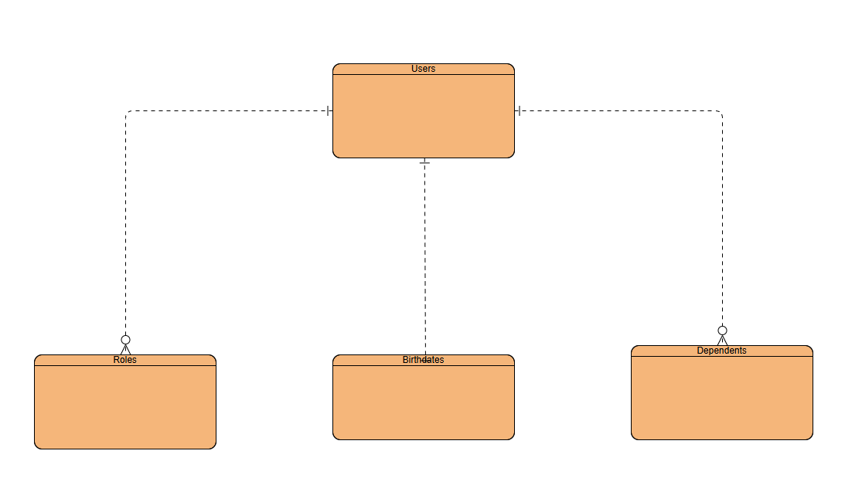

{

"first_name": "Martin",

"last_name": "Fowler",

“birthdate”: 04/20/1968

"roles": [

{

"role_id": "Role_01",

"role_title": "Admin"

},

{

"role_id": "Role_02",

"role_title": "User"

}

],

“dependents”: [

{

dependent_id: “Dependent_01”,

“f_name”: “Damian”

“l_name": "Fowler”

“relation: “Son”

},

{

dependent_id: “Dependent_02”,

“f_name”: “Angela”

“l_name": "Fowler”

“relation: “Daughter”

}

}